Task 1:

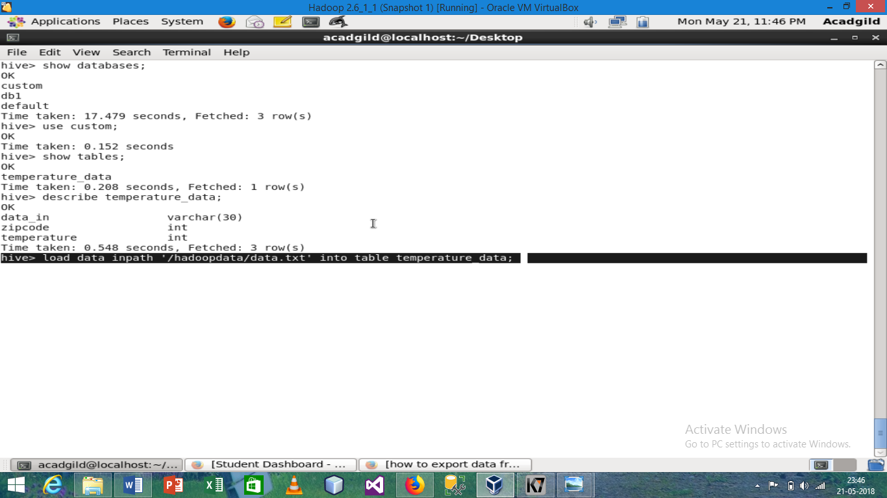

First we create a database custom then we create a table with column name data_in, zipcode, and temperature and finally load the data from text file into table

Task2

Select temperature where zip code is >300000 and <399999

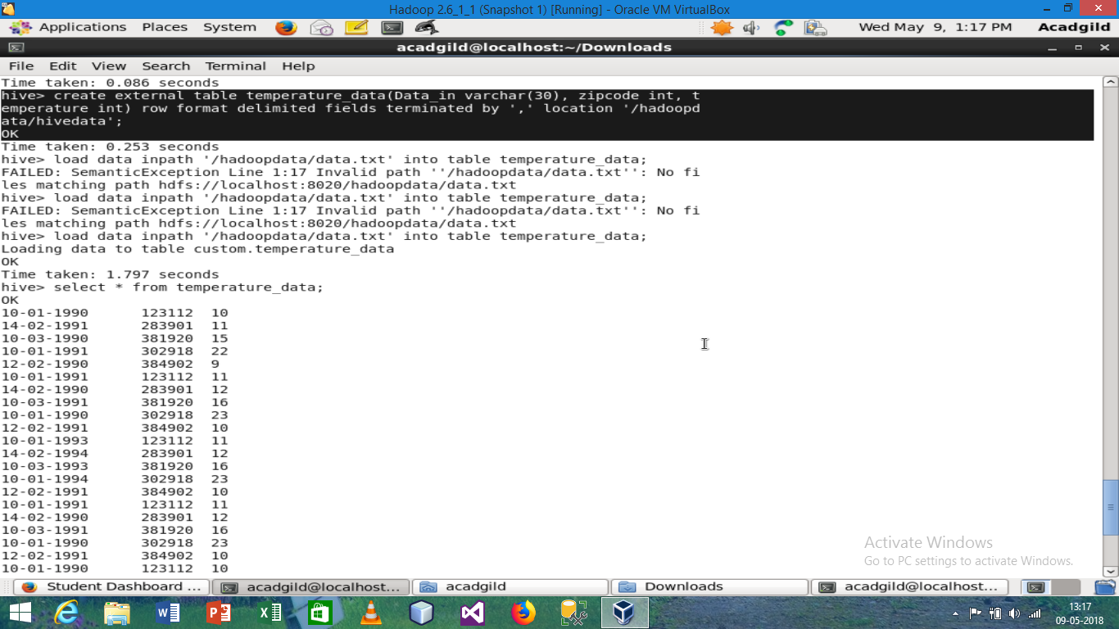

Max temperature corresponding every year

Max temperature corresponding every year with minimum two entry

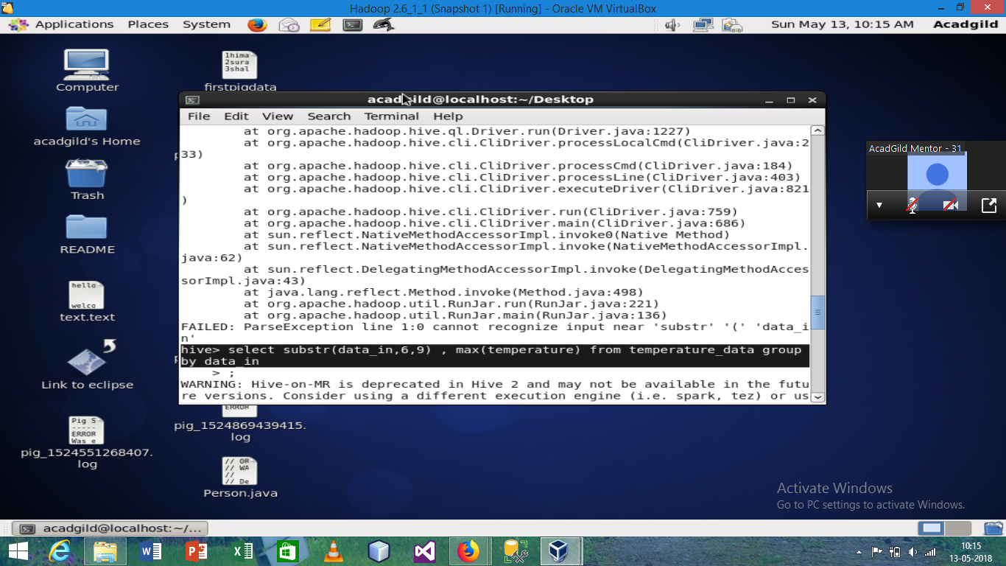

Result

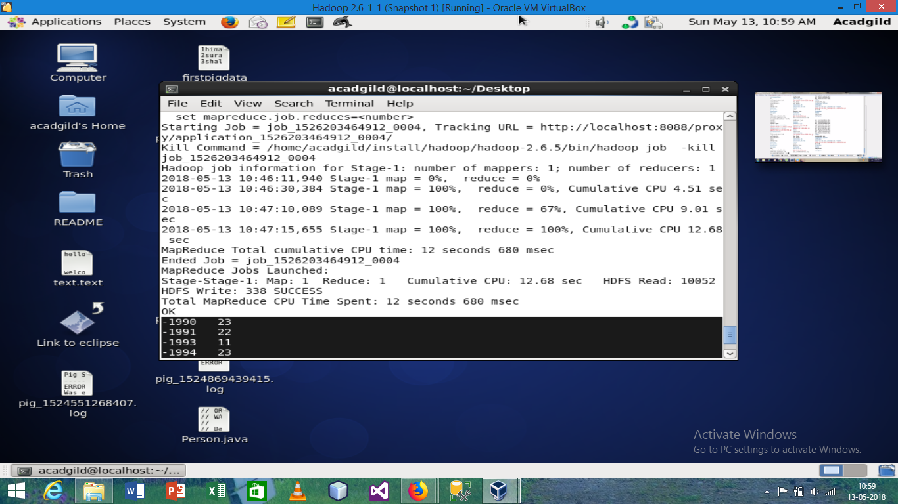

For creating view we use this command

Create view temperature_data_view as select substr(data_in,7,10) , max(temperature) from temperature_data group by substr(data_in,7,10);